**PURE MATHEMATICS 1 PAPER 1v3 WINTER 2021**

**TIME ALLOWED: 1 hour**

**ANSWER ALL THE QUESTIONS**

TOTAL MARKS = 40

**INSTRUCTIONS**: You can use a calculator.

You must show your method.

Answer all the questions.

You must make sure the work you present is yours and is not copied from somewhere else.

**Formulae**

$$a^{2}=b^{2}+c^{2}-2bc\cos{A}$$

$$\cos{A}=\frac{b^{2}+c^{2}-a^{2}}{2bc}$$

$$a^{-n}=\frac{1}{a^{n}}$$

**Questions**

1. Calculate  [2 marks]

$$4\frac{2}{5}-1\frac{3}{7}$$

.

1. A visitor to this country buys a bag costing £47.00 including VAT of 6%. How much VAT can be reclaimed? [4 marks]
2. Find the value of  [2 marks]
$$5+{\left(3-1\right)}^{3}×2$$

3. Simplify $\sqrt{90}$ and leave your answer in the form of $x\sqrt{y}$

[2 marks]

1. Write the equation using positive index. [3 marks]
$$4t^{-3}a^{2}$$

2. Expand [2 marks]
$$\left(2a-b\right)\left(3c+5d\right)$$

3. Expand the expression [3 marks]
$${\left(2a+b\right)}^{4}$$

4. Rearrange the equation to make n the subject. [3 marks]
$$m=\frac{n+3}{2n+5}$$

5. Factorize [4 marks]
$x^{2}-x-12$

$3x^{2}-2x-8$

6. A triangle ABC has sides AB = 3, BC = 5, AC = 10. What kind of triangle is this?

[3 marks]

1. In the diagram below, find the height of the tower. [4 marks]

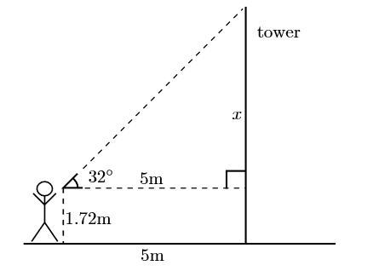

1. Convert [2 marks]
   1. 35 degrees to radian
   2. 1.8 radian to degrees
2. Determine all the angles between $0^{°}$ and ${360}^{°}$ whose tangent is 0.9004. [4 marks]
3. Find the length of side BC in the figure below. [2 marks]

